A New Hampshire
Food Strategy:
How can we create a food system that works for all in the Granite State?

A cross-sector conversation about creating a future food system that strengthens our economy, responsibly stewards our cultural and natural resources, and contributes to the health and well-being of all NH citizens.

DOVER NEW LONDON LACONIA MANCHESTER FREEDOM

KEENE GORHAM NORTH HAVERHILL COLEBROOK LITTLETON

The NH Food Strategy Development process is coordinated by the University of New Hampshire Sustainability Institute (UNHSI) with support from the Henry P. Kendall Foundation, the New Hampshire Charitable Foundation, the John Merck Foundation, Jane’s Trust, and Share Our Strength, in collaboration with the Interaction Institute for Social Change (IISC) and diverse stakeholders from around the Granite State. We thank NH Listens for their guidance and facilitation support.

http://nhfoodstrategy.weebly.com

Welcome and thank you for joining today’s conversation!

Table of Contents

Detailed Agenda 3
Welcome and Overview 3
Desired Outcomes 4
Guidelines for Productive Conversations 4
Key Questions and Priorities 6
Background Information 9

Agenda Overview
8:30 a.m. Registration
9:00 a.m. Welcome and Overview
9:15 a.m. Orientation to Food System Resources
9:20 a.m. Small group conversations
11:20 a.m. Large group summary reports
11:40 a.m. Take-aways and Next Steps
12:00 p.m. Closing

This guide is the same for all participants and facilitators. The facilitators will help guide the conversation but we are all responsible for making sure the group is productive. Thank you!

Detailed Agenda

8:30 - 9:00 a.m. Registration
- Welcome and sign in at the registration table
- Please join your small group circle for the introduction and to start the dialogue immediately thereafter. Please take a few minutes to review the background information starting on page 9, as well as the resources provided for you at your tables.

9:00 - 9:15 a.m. Welcome and Overview from the NH Food Strategy Team

- What is the New Hampshire Food Strategy?
- Who is coordinating the New Hampshire Food Strategy?
- Desired outcomes for today
- Agenda
- Guidelines for productive discussions
- Overview of information in discussion guide

What is the New Hampshire Food Strategy?

The overall goal of this initiative is to develop a strong and connected Network of organizations, institutions, agencies, businesses, and individuals that contribute to the New Hampshire food system. The ideas, concerns, and hopes that you share today will shape a statewide Strategy that identifies common goals, key leverage points, and action priorities to guide collaboration and action throughout the food system network. As a result of developing this Strategy and food system Network, we hope to accomplish the following:
- identify key leverage points to create a food system that works for all in the Granite State;
- increase networked collaboration across the state and food system sectors;
- identify new market opportunities for producers and food entrepreneurs;
- increase access to all forms of capital for business and community building; and
- support healthy communities, thriving local economies, and equitable access to food for NH citizens for generations to come.
Numerous innovative efforts are already underway across the state to support community and regional food systems; the strategy initiative will help to link and build on these existing efforts, not reinvent the wheel. We are striving to ensure that businesses, groups and individuals who do not often have a voice, are underrepresented in public policy conversations, or our most vulnerable, are also included and involved in appropriate, accessible ways. In order to capture and be informed by state-wide perspectives, we are reaching out across the state to hear directly from those who simply have an interest in food because they live in New Hampshire, to those formally engaged in food system work. Thank you for joining our conversation today. Your voice will help us to shape the future of food in New Hampshire.

Please review the supplemental information in this guide, and our website (http://nhfoodstrategy.weebly.com) to learn more about this process and similar efforts to develop food system strategies or plans in other New England states.

Who coordinates the NH Food Strategy initiative?
The UNH Sustainability Institute (UNHSI), with support from the Henry P. Kendall Foundation, the New Hampshire Charitable Foundation, The John Merck Foundation, Jane’s Trust, and Share Our Strength, serves as the ‘backbone’ organization for the NH Food System Network and Strategy Development initiative. As the backbone organization for the NH effort, UNHSI does not direct or dictate outcomes, but provides administrative and research support, and facilitates meetings and communications among stakeholder representatives across the state. The main roles for the backbone organization include gathering, communicating, coordinating, and organizing information and resources.

In 2013, a diverse group of over 30 food system stakeholders from across the state and food system sectors, met during six, day-long meetings to design the process for developing the NH Food Strategy. This group decided that engaging a broad spectrum of businesses, non-profits, producers, and other citizen leaders, as well as learning about existing efforts around the region, was key to developing a food Strategy for New Hampshire. This team of people (changed somewhat to reflect more diverse perspectives), now called the Strategy Team, will meet again this fall to review the reports from each of the regional gatherings throughout the state and discuss the priority goals and actions to be included in the statewide Strategy. Beginning in 2015, all stakeholders will have the opportunity to review and provide input on the draft Strategy.

More information about the Strategy Team members and the Strategy Development Process can be found on our website: http://nhfoodstrategy.weebly.com.

Desired outcomes for our conversation today
- Identify the value of being involved in the Strategy and Network development process.
- Identify short-term and long-term actions that will positively influence the food system and all that depend on it.
- Develop a shared understanding of trends, data, challenges, and innovations in our food system.
- Have opportunities to connect with others doing work across the food system.

A summary report will be created after all 10 gatherings about our conversation today and shared with all participants. You will have the opportunity to provide feedback about that report this fall as well as the draft Strategy beginning in January 2015.

Guidelines for productive conversations

This conversation today is…
- Designed to focus on what is important to you related to the food system in the state of New Hampshire.
- Designed for participants to be here the whole time (please do what you need to do to be most present: feel free to take a break or step outside for a phone call if needed).
- About a constructive focus and looking forward to desired actions and solutions.
- Organized to allow the greatest possible time for everyone to both speak and listen, which is why we use small, facilitated groups where ideas can be explored, differences understood, and preferences for action expressed.

Group agreements for a productive conversation…
- Share “air time.”
- If you disagree, consider asking a question rather than arguing to prove your point.
- It’s OK to disagree, but don’t personalize it. Stick to the issue, not the person who is disagreeing with you.
- Speak up if the process doesn’t seem fair.
- Speak for yourself, not for others and not for an entire group (use “I” statements).
- Personal stories stay in the group unless we all agree we can share them outside of the group.
- We all share responsibility for making the group productive.
- Be respectful and use respectful language.
- Respect the facilitator’s role.
- Listen first.

Please note: We are delighted to have this event covered by the press and local bloggers and want to balance that with a participant’s ability to express an incomplete or experimental thought as a part of this process. We respectfully request all representatives of the news media (formal and informal) ask permission to tape, photograph, identify, or quote an individual participant directly. We are happy to answer any questions about this request.

9:15 - 9:20 a.m. Orientation to Food System Resources
- Brief orientation to the data and resources available to you, including the figures at your table, the NH Food System Diagram, Infographic, and state data, as well as other New England food system reports. Quantitative data helps give us a more comprehensive understanding of the food system, allows us to see the gaps and understand challenges, as well as guide us in the development of the NH Food Strategy. You will have time in your small groups to respond to and discuss this data.

Small Group Discussions

9:20 - 9:35 a.m. Introductions in small groups

Your small group has a neutral facilitator whose role is to
- help with the process and keeping time,
- serve as a reminder of our agreements to be fair and respectful,
- make sure everyone gets a chance to participate, and
- record key information for the Summary Report.

Reminder: Your group will need someone to report out to the large group at the end.

Introductions: Please share…
- Your name
- Your role within the NH food system (reference diagram p. 10). For example: community leader, business owner, producer, health care provider, volunteer, etc.
- A brief hope you have for New Hampshire’s food system

*RECORD: Please note the hopes for the NH Food System during introductions (#1).

9:35 - 9:45 a.m. Review Figures

Review the NH Food System Diagram, Infographic, and figures at your table within small groups. These data sources are intended to provide background for the NH food system. Take a few minutes to review these figures and note any thoughts, questions, or concerns that come up for you. Feel free to pose questions to your small group, and write any questions that you have about the data on the cards provided at each table. These cards will be collected toward the end of the gathering. We will respond to all questions, posting a list of both the questions and answers on www.NHFoodStrategy.Weebly.com.

9:45 - 11:20 a.m. Key questions and priorities

Consider the overarching question:
How do we create a food system that works for all in the Granite State?

We’ll begin to address this question by talking about our experiences and perspectives regarding opportunities and challenges we see in the food system, priority actions or solutions we might take to address those issues, who in the group or elsewhere in the state might be able to take on some of the identified priority actions or solutions, and how a statewide Network can help us to collaboratively achieve our goals.

It might be useful for each person to speak briefly about their perspective and key questions.
The following questions may be helpful to prompt your thinking:
9:45-10:10 a.m. Building a Food System Network in NH
- Share some of your experiences, stories, current projects, etc. relating to the food system in NH. Who are you working with? What are you doing?
- How would a more connected network function? What would it look like?
- What has been your experience with collaborating with other food system sectors/regions to achieve mutual goals?
- In what ways could you envision yourself collaborating more closely with others across your region/NH to create win-win scenarios for the food system?
- How could your work enhance the work of others across your regions/NH?
- How/what could work from other regions do to enhance your work?
- What are the barriers to working across sectors/across regions in NH?

10:10-10:35 a.m. Opportunities and Challenges
- Going back to your role - Who IS the food system working for/Who ISN’T it working for? IS it working for you? If yes, how? If no, how?
- How IS the food system working/How is it NOT working? How IS/ISN’T the food system working for your organization/business, etc.
- What are some challenges or opportunities particular to your region of NH?

10:35-11:00 a.m. Actions and Solutions
- If you had all the resources necessary, what would you do? What would you change? What would you be working on?
- What are some “low-hanging fruit” actions or solutions to the challenges you see in the NH food system?
- What are some goals we want to achieve, and strategies for accomplishing those goals (NH region or state)?
- What can be done so the food system works better for you, your organization, business, agency, etc.?
- Who on the ground is working on or could help make suggested actions happen? Think sub-state regional and/or state level. Who = YOU, your business, organization agency, etc.

*RECORD: Note the primary concerns and priorities mentioned when people discussed the key questions (#2, #3, #4).

Spend time here exploring differences and commonalities in your group. What questions remain? Has anyone gained insights or new understandings? Are there any new ideas to note?

We are hoping to build a network of organizations, businesses, and individuals like you whose work intersects with the food system in fundamental ways. Where do you think we can be most effective?

11:00 - 11:20 a.m. Final Priorities
Based on your group conversation, ask each other: “Are there any common-ground thoughts or ideas in this group? If so, what do we want to say at the end of the evening? If not, what diverse points of view do we want to convey?”
- How can we continue to work effectively as a network?

A single consensus is not required, but if one emerges, or perhaps if the group wants to put forward two or three primary points of view, that is fine. These will represent your key findings and recommendations.

Your group will need to prioritize their top insights, etc. to report out to the large group and select someone to speak. The reporting out should include no more than two or three specific statements. To arrive at this point, the group should take a step back and look for both the unique ideas and those that seemed to recur. Group ideas together that seem to be related, but don’t lose track of the unique ones.

The small group written report will convey a more complete view of your group’s ideas for the overall gathering report (this will be taken directly from the flip chart notes and will be included directly in the report as finalized by your group). You will likely not have time to represent all of your ideas in the large group report out (two minutes!).

*RECORD: What are your group’s key findings and recommendations? (#5)

If you have time…

*RECORD: Please add any additional information that your group feels is important to pass along in the summary report (#6):

11:20 - 11:40 a.m. Reporting Out
Each group will be asked to provide a VERY BRIEF summary of their most important findings, concerns or recommendations. If you are asked to speak for your group, please be brief and share what has been compiled by your group, including common ground and divergent views. (You will have two minutes!)

11:40 a.m. - 12:00 p.m. Next Steps and Closing
Quick share across the room- popcorn style: One key takeaway from this event

Next steps - for the UNHSI backbone team and Strategy Team
- The UNHSI Backbone organization will pull together all of your input and feedback from today’s gathering and compile into the first draft of a food strategy identifying key leverage points, goals, and strategies.
- This draft strategy will then be reviewed by YOU and the Strategy Team to help us distill the input even further.
- A follow up gathering will be held involving all interested stakeholders to identify next steps for expanding goals, honing in on short-term and long-term strategies to achieve those goals, and identifying a structure for implementing this strategy.
- In parallel to the strategy development, a network structure will be developed as identified by your needs and suggestions today. UNHSI aims to provide guidance, support, and technical assistance for this network as needed moving forward.
Next steps - for all of you
- Encourage others who you feel should be a part of the conversation to attend a regional gathering, visit us on the web to provide feedback, or call a Backbone Organization or Process Team member to share your thoughts.
- Review the draft report when it is posted on the website.
- Attend future gatherings of this developing Network to further refine our goals and strategies and to help carry them forward.

Please fill out the evaluation – it matters to us! We read these and always work to incorporate your feedback. Thank you!

The report from this event will be posted on the NH Food Strategy website by early fall.
THANK YOU!

Background Information
The information in this section is a compilation of data, graphics, and indicators related to the food system in NH. The data provided is meant to serve as a snapshot of NH’s food system to provide some perspective across the state, across the region, and across food system sectors. Additional data and reports will be made available on our website, www.nhfoodstrategy.weebly.com.

Who are the Process Team Members?
This team of people from around the state will be instrumental in continuing to design the process for developing the NH Food Strategy as well as guide the structure for the NH Food System Network. They will assist with synthesizing input from around the state to draft the NH Food Strategy.

- Rebecca Brown, Executive Director, Ammonoosuc Conservation Trust, New Hampshire State Representative, Grafton County District 2
- Dr. Lynda Brushett, Senior Partner, Cooperative Development Institute
- Dr. Erik Chapman, Fisheries Assistant Extension Professor, NH Sea Grant/UNH Cooperative Extension
- John Hamilton, Vice President of Economic Opportunity, New Hampshire Community Loan Fund
- Dr. Tom Kelly, UNH Chief Sustainability Officer, University of New Hampshire
- Dr. Joanne Burke, UNH, Clinical Associate Professor in Nutrition, Director of Dietetic Internship Program

Who are the Backbone Organization Members?
As the backbone organization for the NH effort, UNHSI does not direct or dictate outcomes, but provides administrative and research support and facilitates meetings and communications among stakeholder representatives across the state. The main roles for the backbone organization include convening, communicating, managing, and organizing resources.

- Jessica Boynton, Program Assistant, NH Food Strategy, UNHSI
- Jackie Cullen, Communications Program Support Assistant, UNHSI
- Dr. Erin Hardie Hale, Research and Planning Associate, NH Food Strategy, UNHSI
- Jennifer Wilhelm, Research and Planning Associate, NH Food Strategy, UNHSI

NH Food System Diagram
This food system diagram was drafted in August 2014 by the Process Team as a way to better understand the elements of our food system and how various key players might interact across food system sectors.

Definition: “A food system includes all processes and infrastructure involved in feeding a population: growing, harvesting, processing, packaging, transporting, marketing, consumption, and disposal of food and food-related items. It also includes the inputs needed and outputs generated at each of these steps. A food system operates within and is influenced by social, political, economic and environmental contexts. It also requires human resources that provide labor, research and education.”

NH Food System Infographic
This Infographic depicts a subset of facts about the six indicators chosen to describe the New Hampshire food system. Specifically, the facts help paint a picture of the food system and provide us with reference points for later developing benchmarks and metrics for tracking our progress. This Infographic frames the format of our data collection efforts, and is intended to stir thoughtful discussion about NH's food system. It was developed by the Process Team with input from the Strategy Team, and will be updated periodically as a result of your input and as new data becomes available.

The infographic was created to serve as a dashboard for these food system statistics, highlighting data across six categories including production, distribution and consumption, farm and fishing viability, food access and security, public health, and policy and networking. This document will continue to be refined as a part of the Strategy development process and will continue to serve as reference point for priority actions and solutions within the NH Food Strategy.

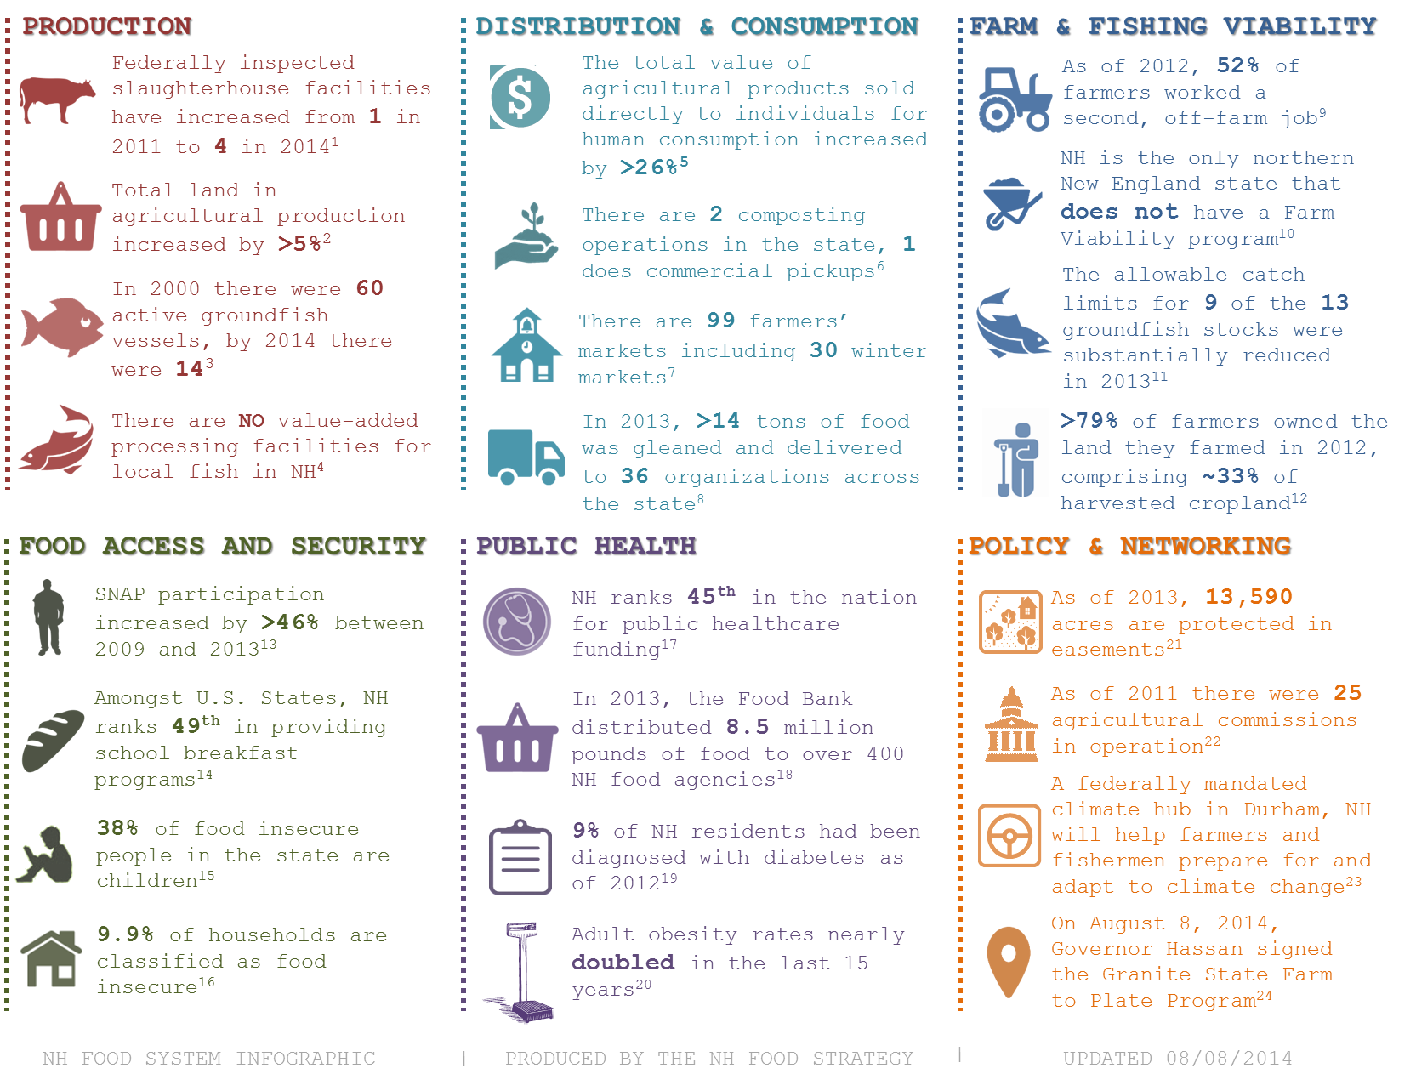

Infographic Citations

- Lewis, C.B., Peters, C.J., 2012. A capacity assessment of New England's large animal slaughter facilities as relative to meat production for the regional food system. Renewable Agriculture and Food Systems 27, 192-199; Gail McWilliam Jellie, DOA, personal communication, May2, 2014
- USDA Agriculture Census, 2012
- Josh Weirsma, NH Groundfish Sectors Manager and David Goethel, Fisherman, Hampton, NH F/V Ellen Diane, personal communication April 16, 2014
- Erik Chapman, personal communication, April 8, 2014
- USDA Agriculture Census, 2012
- Rian Bedard, Chief Executive Composter, Mr. Fox Composting, Personal communication , May 27, 2014
- USDA Agricultural Marketing Service. Accessed 6/3/14. <http://search.ams.usda.gov/farmersmarkets/ >
- NHFTS, NH Gleans report, December 2013.
- USDA Agriculture Census, 2012
- John Hamilton, personal communication, April 8, 2014
- Josh Weirsma, NH Groundfish Sectors Manager and David Goethel, Fisherman, Hampton, NH F/V Ellen
- USDA Agriculture Census, 2012
- Supplemental Nutrition Assistance Program: average monthly benefit per person, data as of April 4, 2014, accessed May 1, 2014.
- Food Research and Action Center, School Breakfast Scorecard: 2012-2013 School Year, accessed May 1, 2014.
- Feeding America, Calculated from Map the Meal Gap data for NH, accessed May 1, 2014.
- USDA report, Household Food Security in the United States in 2012.
- Trust for America's Health, 2013, accessed May 1, 2014. <http://healthyamericans.org/>
- New Hampshire Food Bank, 2014, accessed May 1, 2014. <http://www.nhfoodbank.org/>
- New Hampshire Department of Health and Human Services, accessed May 1, 2014. <http://www.dhhs.nh.gov/dphs/>
- Obesity Prevention Program, NH Department of Health and Human Services, Division of Public Health Services Dec 2010. Childhood Obesity in New Hampshire, 2008-2009
- Purchase of ag conservation easements, status of state programs as of January 2013; Farmland Information Center <http://www.farmlandinfo.org/statistics>
- UNHCE Accessed 5/30/14. <http://extension.unh.edu/New-Hampshire-Agricultural-Commission>
- USDA’s Climate Hubs: Providing Targeted Solutions to Modern Challenges, White House Blog, February 5, 2014, accessed May 1, 2014.
- Citizen.com, accessed August 8, 2014. <http://thecitizen.villagesoup.com/p/governor-signs-farm-bill-into-law-in-tilton/1223777>

