NH Food System Diagram
This food system diagram was drafted in August 2014 by the Process Team as a way to better understand the elements of our food system and how various key players might interact across food system sectors.

Definition: “A food system includes all processes and infrastructure involved in feeding a population: growing, harvesting, processing, packaging, transporting, marketing, consumption, and disposal of food and food-related items. It also includes the inputs needed and outputs generated at each of these steps. A food system operates within and is influenced by social, political, economic and environmental contexts. It also requires human resources that provide labor, research and education.”

NH Food System Infographic
This Infographic depicts a subset of facts about the six indicators chosen to describe the New Hampshire food system. Specifically, the facts help paint a picture of the food system and provide us with reference points for later developing benchmarks and metrics for tracking our progress. This Infographic frames the format of our data collection efforts, and is intended to stir thoughtful discussion about NH's food system. It was developed by the Process Team with input from the Strategy Team, and will be updated periodically as a result of your input and as new data becomes available.

The infographic was created to serve as a dashboard for these food system statistics, highlighting data across six categories including production, distribution and consumption, farm and fishing viability, food access and security, public health, and policy and networking. This document will continue to be refined as a part of the Strategy development process and will continue to serve as reference point for priority actions and solutions within the NH Food Strategy.

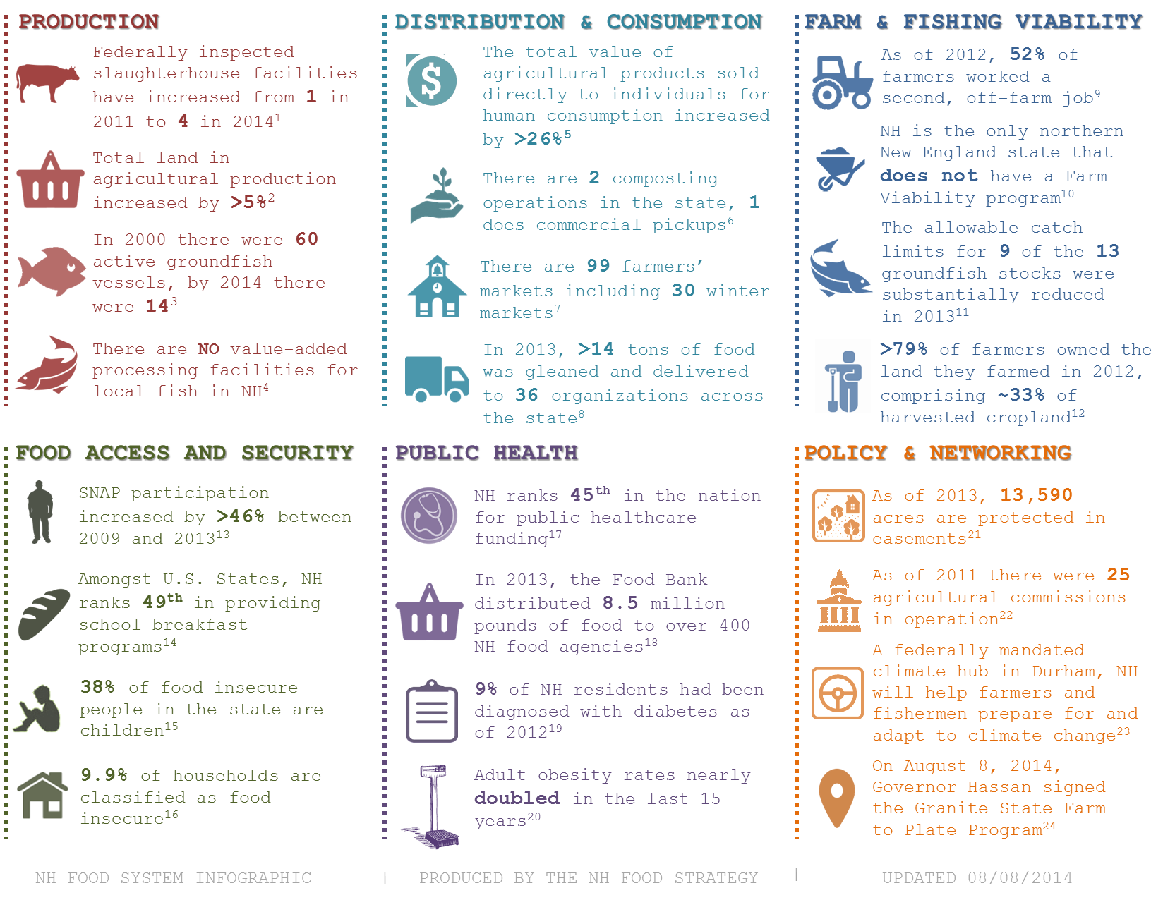

Agricultural Production and Farm Viability

Figure 1. Change in the number of farms and acres of farmland per county in New Hampshire. Data show the number of farms by percent change over time. Of the 225 new farmers between 2007-2012, 121 were female.
County | No. of Farms  2012 | No. of Farms  2007 | % Change  Farms | Acres of Farmland  2012 | Acres of Farmland  2007 | % Change  Acres
NH | 4391 | 4166 | 0.05 | 474065 | 471911 | 0.00
Belknap | 302 | 270 | 0.12 | 23887 | 23387 | 0.02
Carroll | 291 | 274 | 0.06 | 29362 | 32040 | -0.08
Cheshire | 407 | 419 | -0.03 | 63292 | 48241 | 0.31
Coos | 293 | 262 | 0.12 | 56797 | 50895 | 0.12
Grafton | 500 | 552 | -0.09 | 82372 | 99964 | -0.18
Hillsborough | 688 | 615 | 0.12 | 47707 | 50238 | -0.05
Merrimack | 600 | 583 | 0.03 | 64950 | 64642 | 0.00
Rockingham | 658 | 594 | 0.11 | 36003 | 33570 | 0.07
Strafford | 354 | 303 | 0.17 | 30680 | 25744 | 0.19
Sullivan | 298 | 294 | 0.01 | 39015 | 43199 | -0.10
*Data are from the USDA Agriculture Census, 2012

0
10
20
30
40
5
Miles
Ü

Legend
Size of Farm by County

1 to 9 acres

10 to 49 acres

50 to 179 acres

180 to 499 acres

500 to 999 acres

1,000 or more acres

Figure 2. Number of farms by size per county. In NH, over 85% (3,727) of farms are under 179 acres in size. While the southern and eastern parts of the state follow this trend, northern and central NH has larger sized farms. Small-scale farming correlates with the high percentage (>50%) of famers working a second, off-farm job.

*Data are from the USDA Agriculture Census, 2012

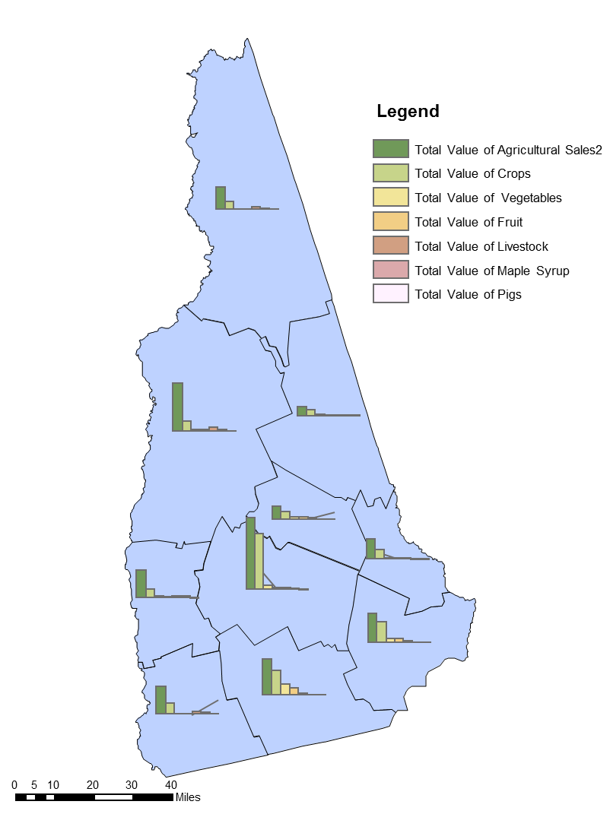
Distribution and Consumption

County | 2012 | 2007 | % change
Belknap | $1,195,000 | $964,000 | 23.96%
Carroll | $1,312,000 | $945,000 | 38.84%
Cheshire | $2,482,000 | $1,355,000 | 83.17%
Coos | $417,000 | $383,000 | 8.88%
Grafton | $1,265,000 | $1,147,000 | 10.29%
Hillsborough | $5,061,000 | $3,706,000 | 36.56%
Merrimack | $2,803,000 | $1,864,000 | 50.38%
Rockingham | $3,301,000 | $3,685,000 | -10.42%
Strafford | $1,169,000 | $1,189,000 | -1.68%
Sullivan | $1,315,000 | $784,000 | 67.73%
NH | $20,321,000 | $16,021,000 | 26.84%
NH Total Ag | $190,907,000 | $199,051,000 | -4.09%
County | 2012 | 2007 | % change
Belknap | $7,765,000 | $7,668,000 | 1.26%
Carroll | $5,471,000 | $5,279,000 | 3.64%
Cheshire | $17,331,000 | $15,406,000 | 12.50%
Coos | $14,199,000 | $13,003,000 | 9.20%
Grafton | $29,831,000 | $34,393,000 | -13.26%
Hillsborough | $22,538,000 | $17,097,000 | 31.82%
Merrimack | $45,266,000 | $55,286,000 | -18.12%
Rockingham | $18,400,000 | $26,035,000 | -29.33%
Strafford | $12,795,000 | $9,912,000 | 29.09%
Sullivan | $17,311,000 | $14,972,000 | 15.62%

Figure 3. Direct-to-consumer sales—from farmers’ markets, CSA’s, and farm stands—are one indicator of local food consumption. NH is following the trend in New England of increased direct-to-consumer sales, increasing the total value of direct sales by >26% between 1997 and 2012. Direct to Consumer sales are 10.6% of total agricultural sales in the state.

Figure 4. Total value of agricultural sales by agricultural sector. Merrimack county had the highest total agricultural sales in NH, at $45,266,000, of which crop, nursery, greenhouse, and vegetables sales accounted for 77%.

Figure 5. Total value of agricultural products sales by county. Strafford county saw a 29% increase in the sales, while neighboring Rockingham county saw a >29% decrease in sales.

*Data are from the USDA Agriculture Census, 2012
Public Health Food Access and Security
Figure 6. Childhood overweight and obesity rates by region. Overweight and obesity rates among youth in NH is on the rise and correlates with the rise in food insecure children. The lack of funding within school food programs, particularly breakfast programs, may also be a contributing factor to the increase in childhood obesity. According to the CDC, in the US children aged 6–11 years who were obese increased from 7% in 1980 to nearly 18% in 2012.
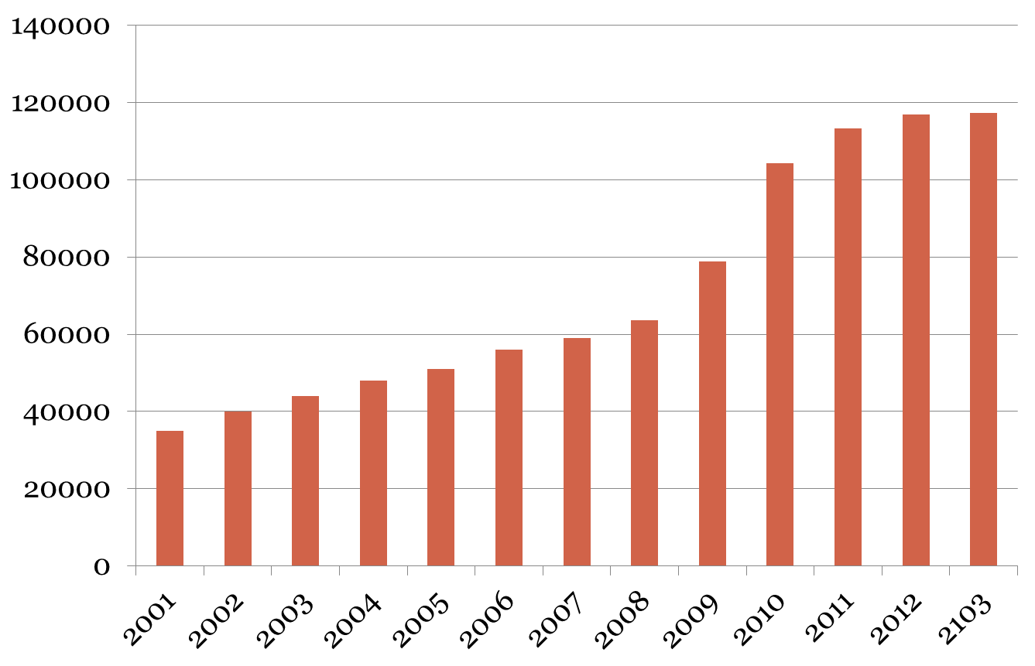
Figure 7. NH has seen a 46% increase in SNAP participation between 2009 and 2013. There are now 56,201 SNAP participants in NH.
New Hampshire Supplemental Nutrition Assistance Program
Participation Rates 2001-2013

*Data are from the USDA Food and Nutrition Service, updated August 8, 2014

46% increase
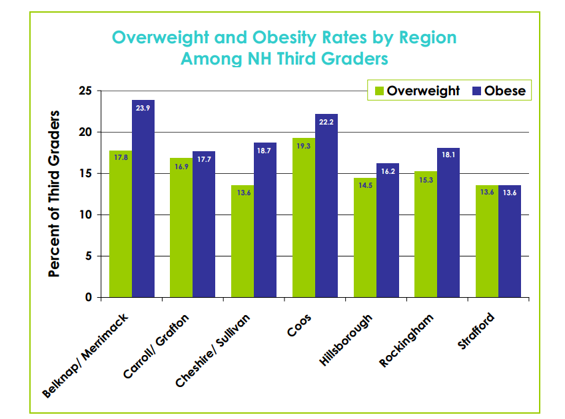
Source: Obesity Prevention Program, NH Department of Health and Human Services, Division of Public Health Services Dec 2010. Childhood Obesity in New Hampshire, 2008-2009

Figure 8. Map of risk of food insecurity by town within the state. The majority of towns at highest risk of food insecurity are located in the northern and western regions of NH. Over 24% of the municipalities in NH are at risk of food insecurity.
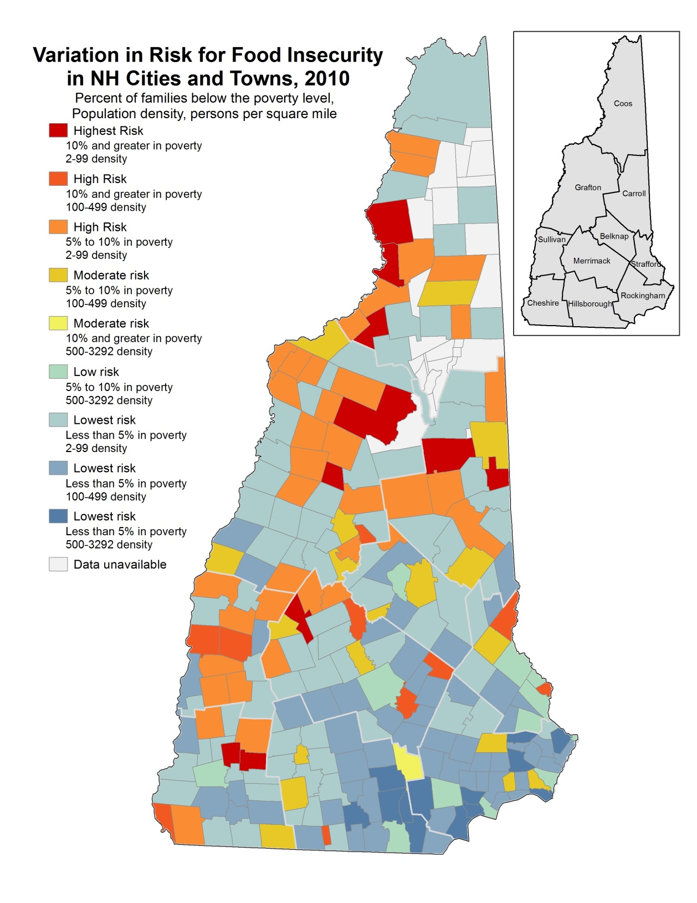

Source: Carsey School of Public Policy, University of New Hampshire, 603-862-2821, http://www.carseyinstitute.unh.edu/ ; New Hampshire Kids Count, 603-225-2264, http://www.nhkidscount.org

Infographic Citations
Policy and Networking

Figure 9. As of October 2011, NH had 25 agricultural commissions in operation, mainly concentrated in the southeastern region of the state. According to the UNH Cooperative Extension, any NH municipality “may establish an agricultural commission to recognize, promote, and encourage farming and agricultural-based economic opportunities, and conserve agricultural land and resources. An agricultural commission has advisory and review authority to work with the boards and agencies of local government. The purpose of an agricultural commission is to protect agricultural lands, preserve rural character, provide a voice for farmers, and encourage agriculture-based businesses and activities.”

- Lewis, C.B., Peters, C.J., 2012. A capacity assessment of New England's large animal slaughter facilities as relative to meat production for the regional food system. Renewable Agriculture and Food Systems 27, 192-199; Gail McWilliam Jellie, DOA, personal communication, May2, 2014
- USDA Agriculture Census, 2012
- Josh Weirsma, NH Groundfish Sectors Manager and David Goethel, Fisherman, Hampton, NH F/V Ellen Diane, personal communication April 16, 2014
- Erik Chapman, personal communication, April 8, 2014
- USDA Agriculture Census, 2012
- Rian Bedard, Chief Executive Composter, Mr. Fox Composting, Personal communication , May 27, 2014
- USDA Agricultural Marketing Service. Accessed 6/3/14. <http://search.ams.usda.gov/farmersmarkets/ >
- NHFTS, NH Gleans report, December 2013.
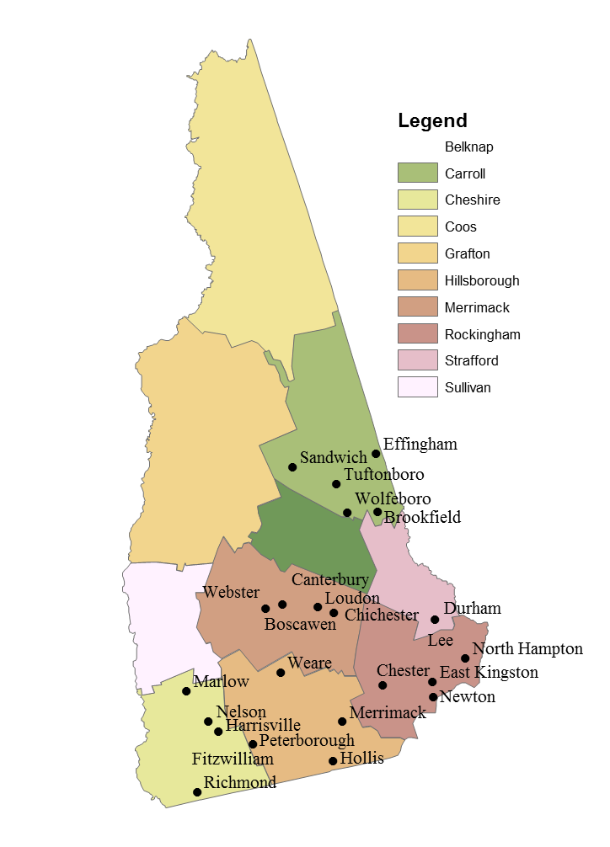
- USDA Agriculture Census, 2012
- John Hamilton, personal communication, April 8, 2014
- Josh Weirsma, NH Groundfish Sectors Manager and David Goethel, Fisherman, Hampton, NH F/V Ellen
- USDA Agriculture Census, 2012
- Supplemental Nutrition Assistance Program: average monthly benefit per person, data as of April 4, 2014, accessed May 1, 2014.
- Food Research and Action Center, School Breakfast Scorecard: 2012-2013 School Year, accessed May 1, 2014.
- Feeding America, Calculated from Map the Meal Gap data for NH, accessed May 1, 2014.
- USDA report, Household Food Security in the United States in 2012.
- Trust for America's Health, 2013, accessed May 1, 2014. <http://healthyamericans.org/>
- New Hampshire Food Bank, 2014, accessed May 1, 2014. <http://www.nhfoodbank.org/>
- New Hampshire Department of Health and Human Services, accessed May 1, 2014. <http://www.dhhs.nh.gov/dphs/>
- Obesity Prevention Program, NH Department of Health and Human Services, Division of Public Health Services Dec 2010. Childhood Obesity in New Hampshire, 2008-2009
- Purchase of ag conservation easements, status of state programs as of January 2013; Farmland Information Center <http://www.farmlandinfo.org/statistics>
- UNHCE Accessed 5/30/14. <http://extension.unh.edu/New-Hampshire-Agricultural-Commission>
- USDA’s Climate Hubs: Providing Targeted Solutions to Modern Challenges, White House Blog, February 5, 2014, accessed May 1, 2014.
- Citizen.com, accessed August 8, 2014. <http://thecitizen.villagesoup.com/p/governor-signs-farm-bill-into-law-in-tilton/122377

